1 INTRODUCTION
1.1 Overview
. To create a business card our institution
. Purpose
To reach the students with the business card

2 Problem Definition & Design Thinking
2.1 Empathy Map

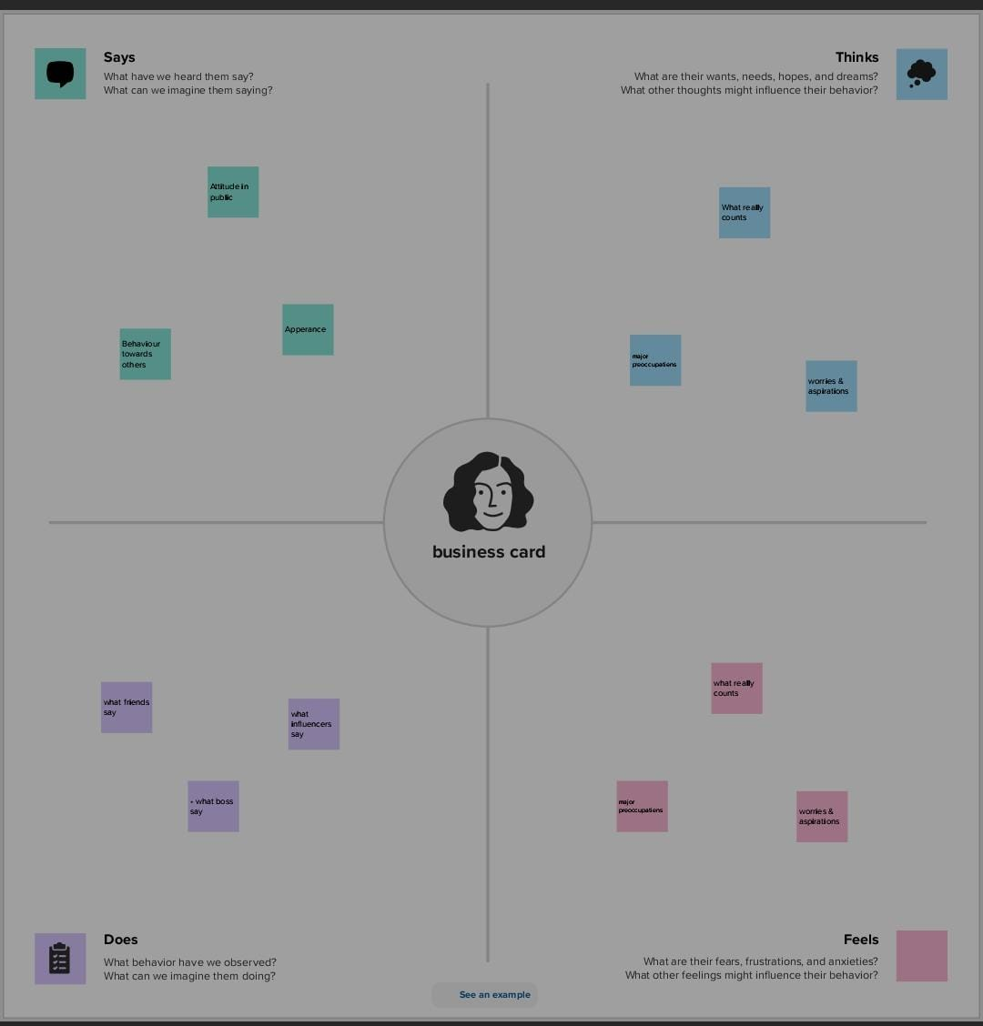

Brainstorming

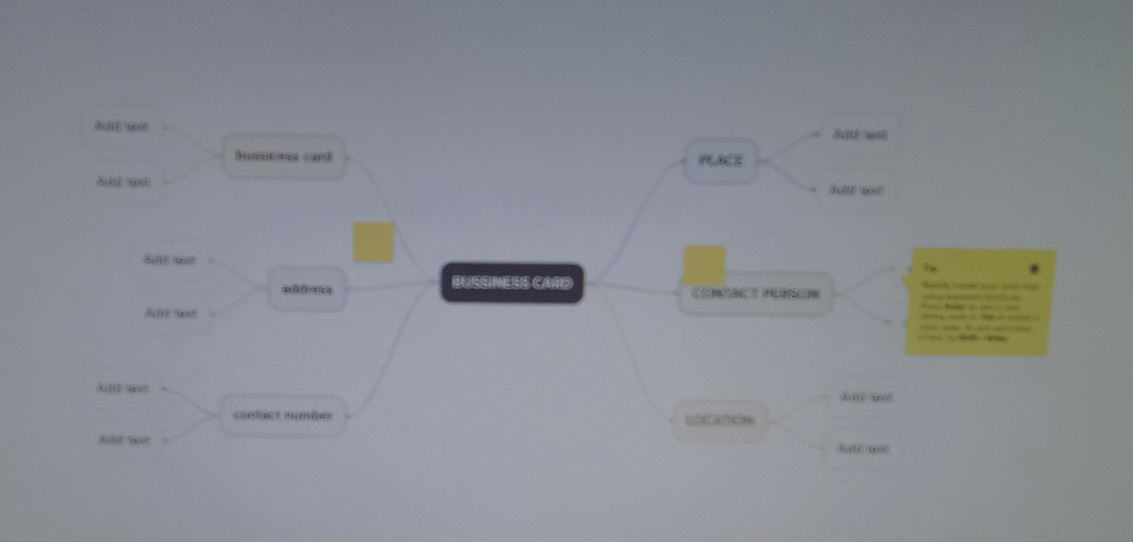

3 RESULT

4 ADVANTAGES AND DISADVANTAGES
.It's easy to reach the people at any time

5 APPLICATIONS
. It can gather all people



6 CONCLUSION
.Successfully created business card using the canva app

